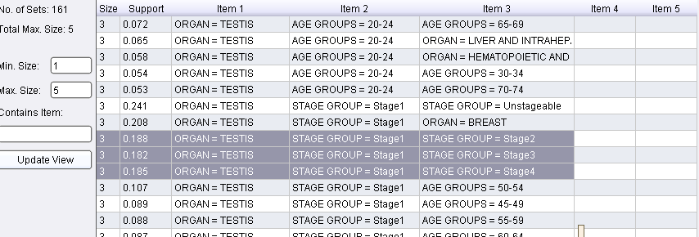

Here multiple stages showing against “Organ=Testis”.

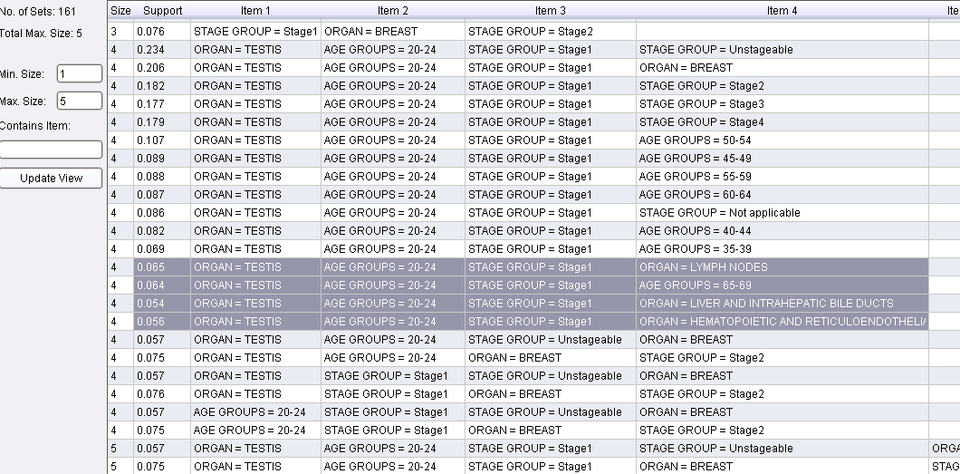

Here multiple organ showing against age group=20-24

